- WEBSITE SPECIFICATIONS

COMPANY: EcoSmart Waste Solutions
Objectives:
To create a website that promotes waste collection and recycling services in Botswana.

Goals:
- Inform users about services
- Encourage recycling
- Allows customers to contact the company
- Build trust and awareness

Target Audience:
- Adults (18-60years)
- Homeowners and small businesses
- Basic internet users (mobile and computer)

Website Type:
- Business information website

2.INFORMATION DESIGN AND TAXONOMY
Site Map: 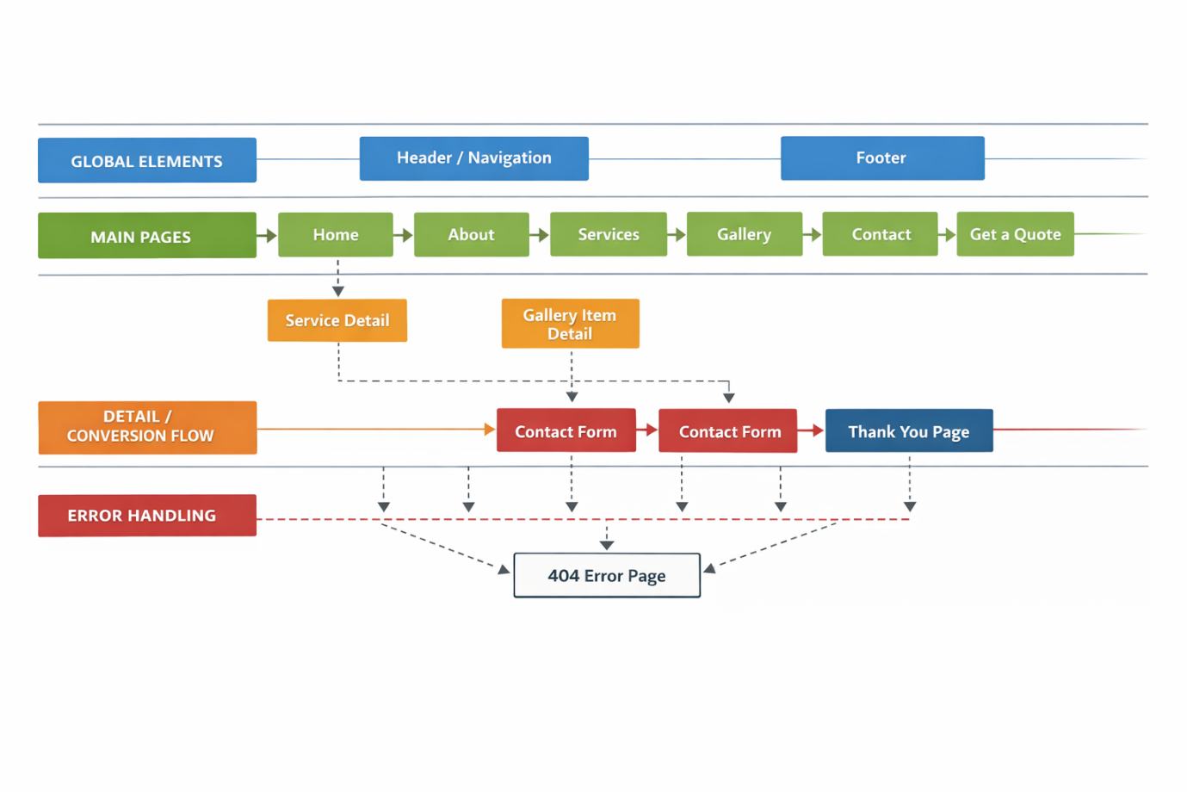

1. Global Lane (Appears on All Pages)
Includes:
Header (logo + navigation menu)
Footer (copyright + links)
Explanation:
These elements appear on every page to ensure consistent navigation and user experience.

2. Main Pages Lane

Pages:
Home
About
Services
Gallery
Contact
Get a Quote
Explanation:
These are the main pages of the website. Users can navigate between them using the menu. Each page provides key information about the company.

1. Home Page
Purpose:
This is the main page users see first.
What it contains:
- Company name (EcoSmart)
- Short introduction
- Navigation menu (links to other pages)
Why it’s important:
It gives users a quick idea of what the company does and helps them move to other pages easily.

2. About Page

Purpose:
Explains information about the company.

What it contains:
- Company background
- Mission (why the company exists)
- Goals (what the company wants to achieve)
Why it’s important:
Builds trust and helps users understand the business.

3. Services Page

Purpose:
Shows what the company offers.
What it contains:
- Waste collection
- Recycling services
- Industrial waste handling
Why it’s important:
Helps customers know exactly what services they can get.

4. Gallery Page
Purpose:
Shows images related to the company.
What it contains:
- Photos of work done
- Recycling activities
- Equipment or environment

Why it’s important:
Makes the website more attractive and shows real work.

5. Contact Page
Purpose:
Allows users to communicate with the company.
What it contains:
- Contact form (name, email, message)
- Possibly phone/email details
Why it’s important:
Helps customers reach the business easily.

Technical Brief
Tools Used:
- HTML5 → structure
- CSS3 → styling
- Bootstrap → simple design
- VS Code → coding
- GitHub → hosting
- Browser (chrome,google,firefox,edge) → testing

